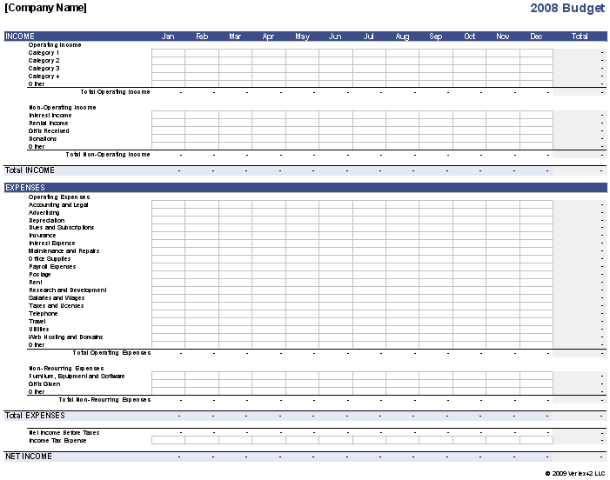

**BUDGETING AND FINANCE**